Volunteer
Manual

Cueto Event Management System | January 2020
Table of Contents
Introduction 3
Supported Devices 3
Contact Info 3
Terms of Use 3
Registration Wizard 4
Registration Page 4
Step 1: Personal Information 5
Junior Agreement 5
Extra Information 5
Photo Upload 5
E-Mail Verification 5
Step 2: Committee Preferences 6
Step 3: Uniform Choices 7
Step 4: Availability 7
Step 5: Payment 8
Home Page 9
Schedule Viewing/Delivery Options 10
Frequently Asked Questions (FAQ) 11
Why do you need to know about my…? 11
Who should I contact for help? 11

Introduction
This guide is intended to cover the volunteer interface for the Cueto Event Management Software. The guide is current as of January 2020 and new versions will be published for each major revision.

Supported Devices
The volunteer site can be used from a computer, tablet or phone. The images in this manual correspond to the computer version. The mobile versions are identical in function, but have a slightly different layout.
If you’re having trouble with the site, make sure that you’re allowing scripts and cookies from the cuetoems.com domain and that your web browser is up to date.

Contact Info
Cueto & Cueto, Inc. is the company responsible for developing, maintaining and hosting the Cueto Event Management Software. We welcome – and appreciate - your questions and feedback about the software, website and manual. We request that you send any questions about the event or volunteer information, such as parking or uniforms, directly to the event staff but we’ll do our best to forward any messages we receive to the correct staff member.
The best way to get in touch with us is through e-mail at john@cuetoems.com. You can also use our contact form:
http://www.cuetoems.com/Contact.aspx
If you’re associated with an event, please put the name of the event in the subject of the message so the correct person gets your message. Due to our travel schedule, it may take us several days to respond.

Terms of Use
This document in its entirety is Copyright 2020 Cueto & Cueto, Inc. It may be copied or distributed, in part or in whole, by any of our customers, or agents acting on their behalf, for purposes of education and training.
This document may not be used for purposes of reverse engineering or duplication of the Cueto Event Management Software.
The most recent version can always be found at:
http://www.cuetoems.com/Help.aspx

Registration Wizard
The volunteer site will guide you through a five-step registration wizard. Some events may not use all five pieces; just skip the corresponding section.

Registration Page
The first time you visit the website you’ll be taken to the registration page where you’ll sign up for a new account on the left side. If you come back to this page in the future, just log in on the right side.
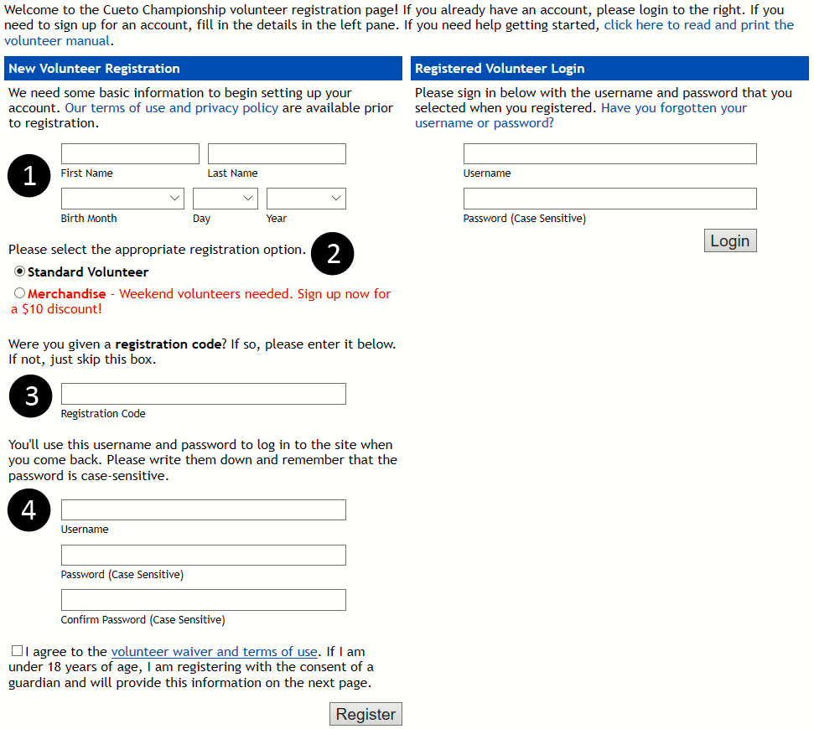
- Enter your first name, last name and birth date.
- Some events offer different types of signups. Select the appropriate for you, or just skip this step if you don’t see any options listed.
- If you’ve been given a registration code, enter it in this box. Some events require registration codes for pre-registration and you will not be able to register without a code.
- Pick a username and password that you’ll use to login in the future. Some events may have you agree to one or more waivers or other agreements via check box.
Once you click the “Register” button, you’ll be shown a welcome message containing the contact information for the event staff, our contact information and a direct link to the site’s login page. Click the link at the bottom of the page to start the wizard.

Step 1: Personal Information
This page helps us collect the information needed to process your application. Your chairperson needs to know how to contact you, so please fill this out completely and accurately, although you can skip any fields marked (Optional).
In addition to your address and contact information, you may see some special sections:

Junior Agreement
Some events allow minors to volunteer, but require a parent or guardian to complete a special agreement. If this is the case, you’ll see a highlighted section appear below the boxes for name and birth date.

Extra Information
Some events have custom prompts, such as demographics questions. If this is the case, you’ll see a new section appear below the emergency contact information.

Photo Upload
Some events may ask all volunteers or just certain committees or registration codes to upload a photograph. If this is the case, you’ll see a highlighted section appear at the bottom of the page. You’ll be asked to select a JPG or PNG from your computer and you can come back and upload, edit or delete this at any time.
Follow the prompts on the page and click the button at the bottom right to proceed to the next step.

E-Mail Verification
After you complete the Personal Information page for the first time and any time you change your e-mail address, the system will send you an e-mail verification message from noreply@cuetoems.com with a clickable link. Please open this message and click on the link so that we know we have accurate contact information for as many volunteers as possible.

Step 2: Committee Preferences
Note: If you are signing up with a registration code that includes a committee assignment, you’ll still see this page but the committee choices will be locked.
This step helps us match you to a committee. You can look at descriptions for all open committees and pick your top three or four choices (determined by the event), as well as list previous experience or special requests.
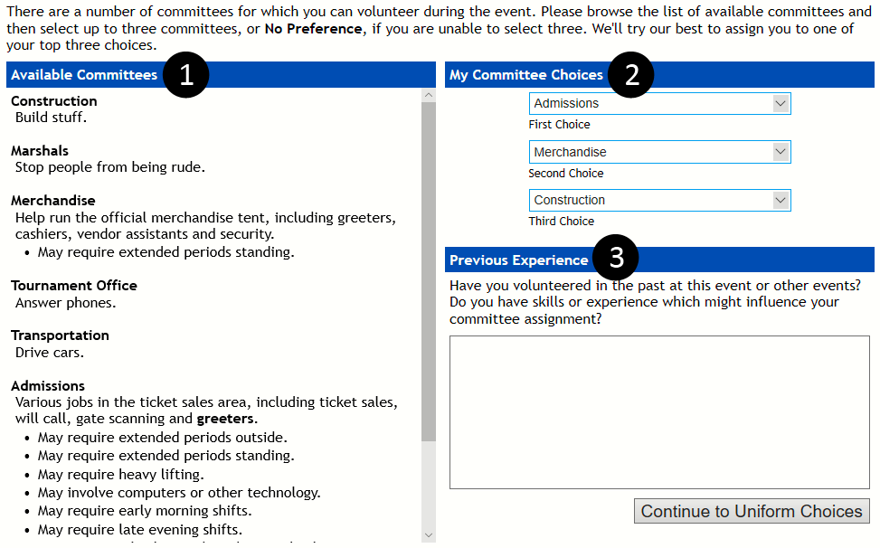

- This section lists all available committees with a brief description and any special indicators, such as requiring extended time outside or long periods standing.
- Use the drop down menus to pick your committee choices. Many events also have a “No Preference” option.
- Use this optional field to explain your past experience at this event or other events and any skills or experience which might influence your committee assignment.

Once you’ve finished making your selections, click the button at the bottom right to proceed.

Step 3: Uniform Choices
This task lets you select your uniform items. Some items, such as headwear, will offer multiple selections to choose from. Other items, such as shirts, may only let you pick your size and color. The items listed depend on the gender you selected on the Personal Information page; if you're seeing clothing for the opposite gender, go back and check your selection.
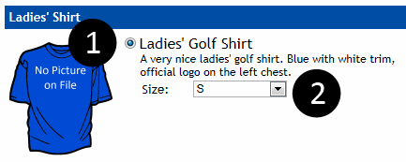
- Use the radio bubble to select an item from a group. The first item in a group will be selected by default; groups with one item will not let you change the selection.
- Some items contain options such as size, color and quantity. Use the drop down menus to select your desired options.
Once you’ve finished picking your uniform items, click the button at the bottom of the page to continue.

Step 4: Availability
This step lets you tell us when you're able to work. We'll try our best to assign you to a committee and work schedule which is compatible with your schedule.
The days displayed, how they are broken down and the minimum number of selections will be different for each event.
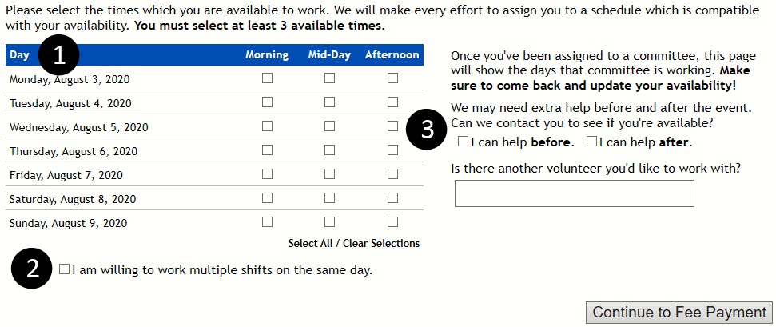
- Use the check boxes to select the times of day you’re able to work. You can use the Select All/Clear Selections buttons to quickly select or clear all boxes.
- Please indicate if you’re willing to work multiple shifts on the same day; event days can be very long and we try not to do so without your consent.
- These fields tell us if you’re able to help before or after the event, and whether you’d prefer to work with another volunteer.
Once you’re finished, click the button at the bottom right to proceed.

Step 5: Payment
Some events charge a volunteer fee to cover uniform costs and other expenses. This final step in the wizard allows you to pay online quickly and safely. If your event does not charge a fee, you’ll see a confirmation instead.

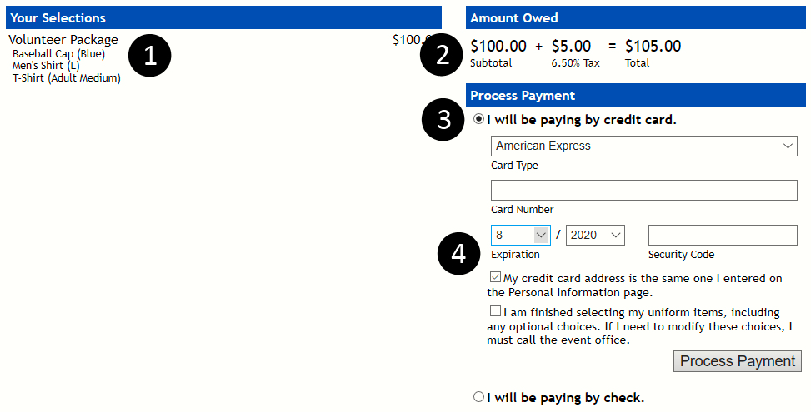

- The order summary shows a list of the items you’re paying for. Items that are included in the standard volunteer package price are not displayed.
- View your order total, split up into subtotal and sales tax. A notification will be displayed if some items are taxed and others are not.
- If the event offers multiple payment methods, such as credit card, check and club account, use the radio bubbles to select your desired payment method.
- Fill out the form fields completely and then click the “Process Payment” button to finish the wizard and go to your home page.

Home Page
Your home page is your customized portal to the event. It’s broken up into four sections:
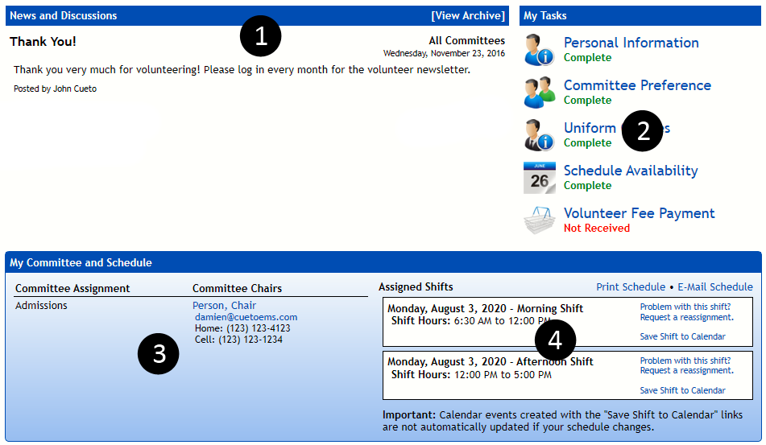
- News and Discussions – Your chairperson(s) and the event staff will post news items with important information and your home page will always show the two most recent posts. You can click the “View Archive” link to see everything that’s been posted in the past. Some posts will have a “Join Discussion” link.
- My Tasks - These icons allow you to see and update the information you entered during the registration wizard. The status of each task is shown underneath the name; a status in green indicates completion, whereas a status in red or yellow requires your attention.
- Committees and Chairs – You’ll see a list of your committee assignments and contact information for your chairs for each committee. You can click a chairperson’s name to message them on-site or their e-mail address to compose a new message in your default e-mail program.
- Assigned Shifts –Your work schedule will become visible closer to the event. The color of your shifts is important:
  - A white shift indicates an assignment that has not been completed.
  - A green shift indicates an assignment that has been completed.
  - A red shift indicates a shift that you've marked for reassignment.

To request a reassignment, click the link labeled "Problem with this shift? Request a reassignment." next to an incomplete shift and complete the prompt.

Schedule Viewing/Delivery Options
In addition to seeing your schedule on the home page, there are a number of ways to save and send your schedule to different devices.
Print Schedule – Access to a printer-friendly version of your schedule.
E-Mail Schedule – Have the system send a copy of your schedule to the e-mail address associated with your account. Parents of junior volunteers who have entered an e-mail address on the Personal Information page will get a copy of this e-mail.
Download Calendar File – Click “Save Shift to Calendar” next to any shift to create a standard calendar file, compatible with almost every mobile device and e-mail and calendar program. Keep in mind that changes to your schedule are not automatically sent to your device, so please double check your assignments.

Frequently Asked Questions (FAQ)

Why do you need to know about my…?
What does your birth date or whether you have a valid driver’s license have to do with volunteering? Actually, quite a bit! Some events and committees may have restrictions on age or require a valid driver’s license and committees that involve interactions with players may involve background checks.
We don’t use or share your data for anything other than your volunteer application and if you truly feel uncomfortable answering a question, you can skip it. We take the protection of your personal information very seriously and you can read our full security and privacy policy at:
http://www.cuetoems.com/SecurityAndPrivacy.aspx

Who should I contact for help?
You're never on your own when you're using our software. In addition to your chairperson(s), the event will assign a staff member to manage volunteers. If you’ve got feedback or suggestions, you're also encouraged to get in touch with our staff member responsible for the volunteer management software. You can e-mail John at john@cuetoems.com.

