Online Credential
Application

Cueto Event Management System | February 2016
The CEMS Online Credential Application lets you enter credential requests for an event online. Your contact at the event will send you a link that will take you to this page:
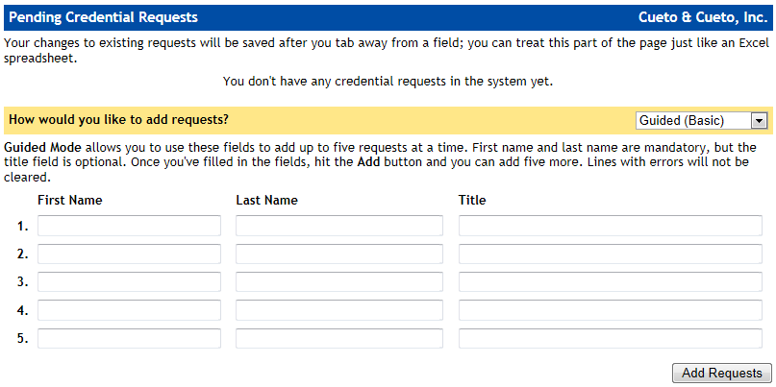
The first time you load the page, you should see your company or organization’s name in the upper right corner and everything else will be blank.

Adding Requests – Guided
New users may prefer the default Guided option for adding requests. In this mode, you use the labeled fields to add up to five requests at a time.
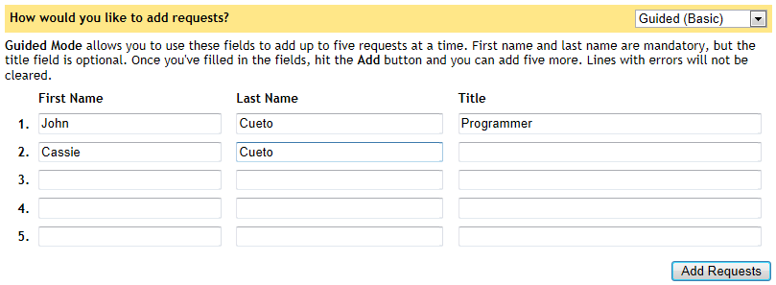
The first and last names are mandatory, whereas the title is optional. Clicking Add Requests will process each line and you’ll see the requests appear at the top of the page. Lines with errors (such as forgetting a first or last name) will remain.

Adding Requests – Free-Form
Advanced users may prefer the faster Free-Form option, which allows you to use a text box to add an unlimited number of requests at a time.
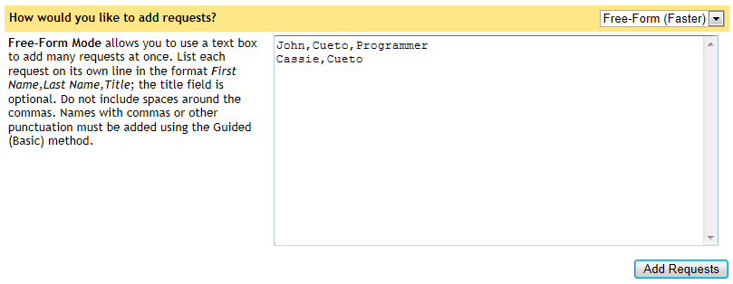
As you can see in the graphic above, each request must go on its own line with the fields separated by commas. There are no spaces around the commas and the last field for title is optional. Clicking Add Requests will process each line and you’ll see the requests appear at the top of the page. Unlike the Guided mode, lines with errors are simply discarded.

Editing and Deleting Requests
Once you have at least one request in the system, the top half of the page will become an editable list.
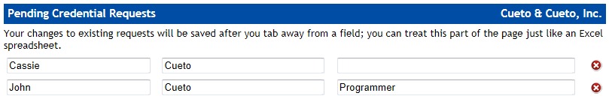
You can modify the first name, last name and title for any of your pending requests. Just like an Excel document, your changes are saved as soon as you tab away from a field. If you’ve made a mistake and need to undo a change before tabbing away, hit the Escape key.
To delete a request, click the red X symbol to the right of the line; you’ll be asked to confirm the delete operation and given a chance to cancel.

Approved Requests
Requests will automatically disappear as they are approved or denied by the event staff and subsequently imported into the credential system.

