Chairperson
Manual

Cueto Event Management System | January 2020
Contents
Introduction 4
Contact Info 4
Terms of Use 4
Home Page 5
Committee Alerts and My Tasks 6
Alerts 6
Schedule Problems 6
New Volunteers 6
Hidden Schedules 6
My Tasks 6
Personal Information 6
Uniform Choices 6
Extra Item Payment 6
Tools and Reports 7
Account Creation (Usually Hidden) 7
Assignment History 7
Availability Table 7
Generic Check in Sheet Printer 8
Manage Shifts 9
Staggered Shifts 9
Cloning Shifts 9
Messaging by Schedule 10
My Committees 11
Print Schedule 12
Report: Assignments by Hour 13
Report: Attendance 14
Schedule Problems 14
Search Directory 15
Shift Check In 15
Real Time Name Search 16
Right-Click Quick Task/Location Change 16
Check In Stub 16
Notes 16
Schedule by Grid 16
Schedule by Person 17
Schedule by Shift 18
Volunteer News 19
Messaging 21
Messaging a Single Person 21
Via The Directory 21
Via My Committees 21
Messaging Multiple People 21
Via My Committees 21
Tracking E-Mail Read Status 21
Frequently Asked Questions (FAQ) 22
How do I set up an account? 22
How do I print an address book for my committee? 22
How do I print the Availability Table? 22
What are the steps to schedule a volunteer? 22
Who should I contact for help? 22

Introduction
This guide is intended to cover the tools and reports which make up the chairperson interface for the Cueto Event Management Software. The guide is current as of January 2020 and new versions will be published for each major revision.

Contact Info
Cueto & Cueto, Inc. is the company responsible for developing, maintaining and hosting the Cueto Event Management Software. We welcome – and appreciate - your questions and feedback about the software, website and manual. We request that you send any questions about the event or volunteer information, such as parking or uniforms, directly to the event staff but we’ll do our best to forward any messages we receive to the correct staff member.
The best way to get in touch with us is through e-mail at john@cuetoems.com. You can also use our contact form:
http://www.cuetoems.com/Contact.aspx
If you’re associated with an event, please put the name of the event in the subject of the message so the correct person gets your message. Due to our travel schedule, it may take us several days to respond.

Terms of Use
This document in its entirety is Copyright 2020 Cueto & Cueto, Inc. It may be copied or distributed, in part or in whole, by any of our customers, or agents acting on their behalf, for purposes of education and training.
This document may not be used for purposes of reverse engineering or duplication of the Cueto Event Management Software.
The most recent version can always be found at:
http://www.cuetoems.com/Help.aspx

Home Page
Your home page is your customized portal to the event and your committees. It’s broken up into three sections:
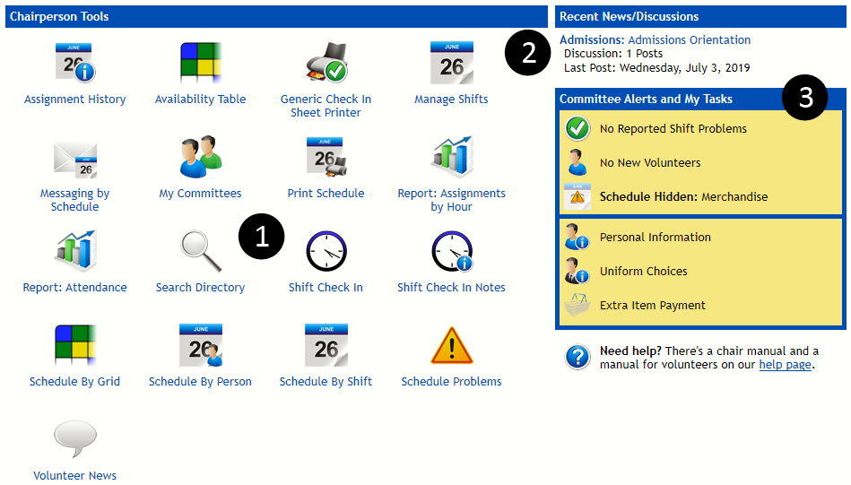
- Tools and Reports – Depending on which tools your event has made available to chairs, you’ll see up to 18 icons, each representing a tool or report. These are detailed in the section “Tools and Reports” and can be run by clicking on the icon. You can see the 17 most commonly visible icons above.
- News Activity – Displays up to three of the most recent news posts, based on posting date and discussion activity. To go to a post to participate or moderate the discussion, click the title of the post.
- Committee Alerts and My Tasks – These icons allow you to quickly access your personal profile information and view critical alerts, such as new volunteers, scheduling problems or committees with hidden schedules. These are detailed in the next section, “Committee Alerts and My Tasks”.
If you ever misplace this document, you’ll also see a link to the chairperson manual under the Committee Alerts and My Tasks, which will take you to our Help page and the most recent version of the manual.

Committee Alerts and My Tasks

Alerts
Schedule Problems  The Schedule Problems alert will display when one or more volunteers have indicated a problem with their current shift assignments. Clicking the alert will take you to the Schedule Problems tool described later. | 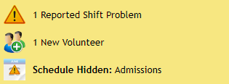  The alert section showing a sample alert of each type.  The alert section showing no alerts.

New Volunteers
The New Volunteers alert will display when new volunteers have joined your committee(s) any time within the past week. Clicking the alert will take you to the Assignment History tool described later.

Hidden Schedules
The Hidden Schedules alert will display if you’ve hidden schedules from being displayed on the volunteer home page. Clicking the alert will take you to the My Committees tool described later.

My Tasks
You may have finished these tasks as part of the registration process, but you can come back and update your information at any time.

Personal Information
The personal information page collects information on your residence, contact information and emergency contact information. The e-mail address and phone number(s) you enter here will be shown to your committee members; everything else is kept private.

Uniform Choices
If your event has uniform choices, this icon will allow you to select from those choices, including extra paid items. Pick one item from each group using the bubbles, then select a size and/or color, if applicable. You may freely change these selections until you submit payment.

Extra Item Payment
If your uniform choices include paid items or your event is charging a volunteer fee, this page will allow you to submit your payment online. If you want to pay by credit card, follow the instructions to process the payment immediately. If you want to pay by check, click the “Pay by Check” bubble to see check payment instructions.

Tools and Reports

Account Creation (Usually Hidden)
This tool lets you manually create a volunteer account. You probably won't need to use it much - most volunteers will create an account through the normal registration process.

- Pick a username and password for the new volunteer. If you pick a username that's already in use, the system will ask you to pick another.
- Using the drop-down list, pick the committee to which the new volunteer should be assigned. Depending on the event's rules, you may only able to create accounts for your committees.
- Enter the volunteer's first and last name. If you know the volunteer's personal information, you can fill in the Volunteer Details section; if not, just skip it.
- Click the "Create Account" button at the bottom of the page. After the account is created, you can go back to your home page or create another account.

Assignment History
This tool lets you view the registration date and committee assignment date of the volunteers in each of your committees. If you manage multiple committees, use the dropdown menu to change the selected committee.
Volunteers who have been assigned in the past week will be highlighted in green. Click on a volunteer's name to go directly to their profile page.

Availability Table
This tool displays a grid, with volunteers listed down the left and events days listed across the top. Depending on the structure of your committee’s shifts, the blocks may be broken down into AM/PM, Morning/Mid-Day/Afternoon, or another configuration. Cells are shaded based on a volunteer's status regarding that time of day:
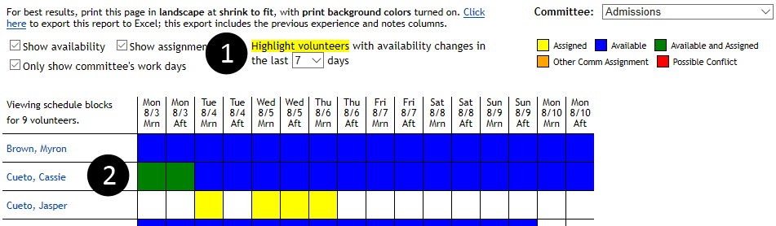
The controls at the top of the page allow you to filter the information displayed and export the table to Excel as a CSV file if you’d like to do custom formatting.
Availability blocks are color coded as follows:
- Blue – Volunteer is available for this shift, and not currently assigned.
- Green – Volunteer is both available for and assigned to this shift.
- Yellow – Volunteer is not available, but has been assigned to this shift. This is OK if you’ve done it on purpose.
- Orange – Volunteer is assigned to another committee as this time. You should not assign the volunteer to this shift.
- Red – Volunteer is assigned to overlapping shifts on this committee and another committee. You should fix the schedule conflict.
The bottom of the table will show totals and can be toggled between a basic display:
Or a detailed breakdown:
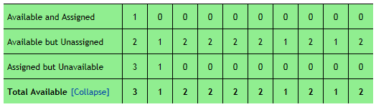
You may have trouble printing this page on some browsers. Check out “How do I print the Availability Tale?” section of the FAQ on the last page.

Generic Check in Sheet Printer
This tool allows you to create check in sheets or grids with volunteers down the left side and columns based on dates or quantities across the top. It’s not a replacement for the schedule printing tools but instead can be used for tracking meals, orientation attendance, etc.
- Use the Committee check boxes to select which committee(s) to include on the sheet.
- Use the Columns check boxes to select dates and/or enter a quantity of blank columns.
- Select the output format and then click Print.

Manage Shifts
This tool lets you create, modify and delete shifts, to which you can later assign volunteers. You can manually create shifts for each day, or set up the shifts for one day and clone them to the rest of the event week and then fine tune each day's times.
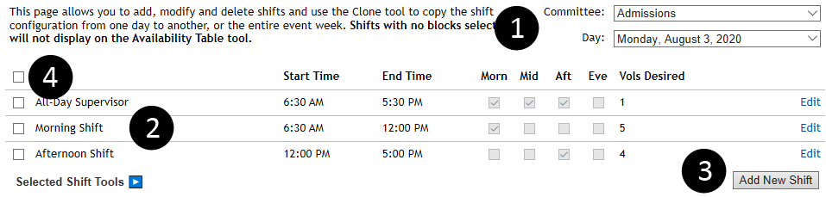
- Pick the committee and day you want to work with.
- Existing shifts are displayed in the table. Clicking Edit will allow you to change the name, times, associated availability blocks and how many volunteers you’d like assigned.
- Clicking Add New Shift will open a dialog to walk you through creating a new shift.
- Use the check boxes to select one or more shifts, and then hover over Selected Shift Tools to see a menu of tasks which apply to the shifts you’ve selected.
  - Quick Adjust Times allows you to add or subtract time from the selected shifts, such as delaying a day’s schedule by 15 minutes.
  - Set Time(s) of Day allows you to select or unselect any of the four times of day (Morn, mid, Aft, Eve) from the selected shifts.
  - Delete will remove the selected shifts from the system, after prompting you for confirmation.
Staggered Shifts  The staggered shifts tool allows you to automate the creation of multiple shifts that occur at regular intervals, such as walking scorers.  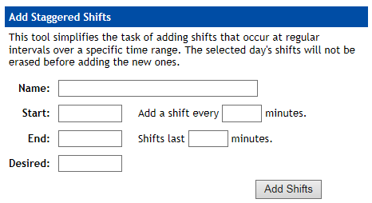  Fill in each field and click Add Shifts to start the process. | Cloning Shifts  The shift clone tool allows you to copy shifts from the selected day to another, or the entire event week. Simply pick your target and hit Clone.  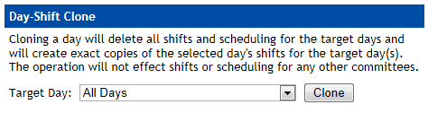  Be aware that cloning shifts will erase the target days’ shifts. This cannot be undone, so please use care when cloning or deleting shifts. If you’re unsure, please ask a staff member for help.

Messaging by Schedule
This tool allows you to quickly compose a message to your volunteers based on various schedule criteria. Common uses include notifying specific shift(s) of a schedule change or announcing a weather delay or cancellation for everyone working at a certain time of day.
Begin by selecting filter criteria on the left, then clicking the Load Matching Shifts button. | For instance, these filters would select all Admissions volunteers working Monday – Wednesday. | These filters would select all of your volunteers working on a weekend afternoon.
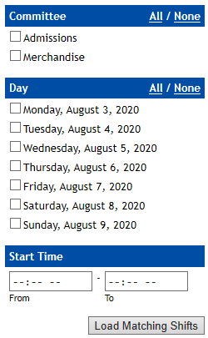 | 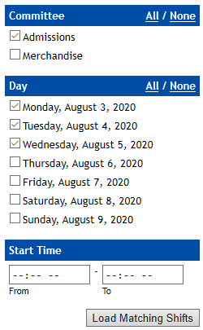 | 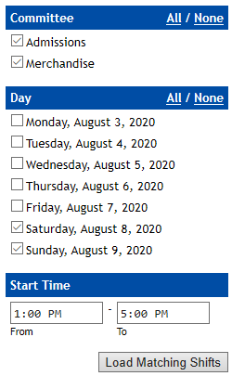

After clicking Load Matching Shifts, the system will show you a list of all matching shifts:
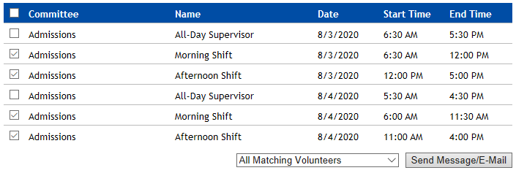
Use the check boxes to select at least one shift (or the master check box to select all displayed shifts) and use the drop down to select the matching volunteers or filter by check in status, then click the button to compose the message.

My Committees
This tool gives you an overview of all committees you manage, including basic options, a complete roster for each committee with a status for each volunteer and various communication options within each committee. The top half is made up of the roster:
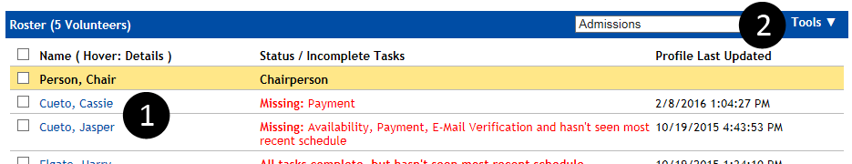
- For each member of your committee, you’ll see the name, the status of their tasks (such as payment and filling out personal information) and the date that they last logged in. Hover over a person’s name with the mouse pointer to see a popup window with more information. Other chairs in your committee are listed first, with a highlighted background.
- The Tools menu allows you to perform tasks with volunteers you’ve selected by checking the boxes next to their name. It includes:
  - Message Selected – Send an on-site message and/or e-mail to the selected people.
  - Print Schedules – Generate a PDF document with a separate page for each selected volunteer’s schedule.
  - E-Mail Schedules – Send each selected volunteer an e-mail containing their schedule. You’ll be taken to the E-Mail Schedule screen which allows you to customize the message and confirm delivery.
  - Export Address Book – Generate a CSV file containing the names and contact information for the selected volunteers.

If you are the chairperson for multiple committees, you will see two more options:
- Message Committees – Send an on-site and/or e-mail to any or all of your committees at once.
- Manage Committee Assignments – Move volunteers between your committees.

The bottom half of the screen contains various options and scheduling tools:
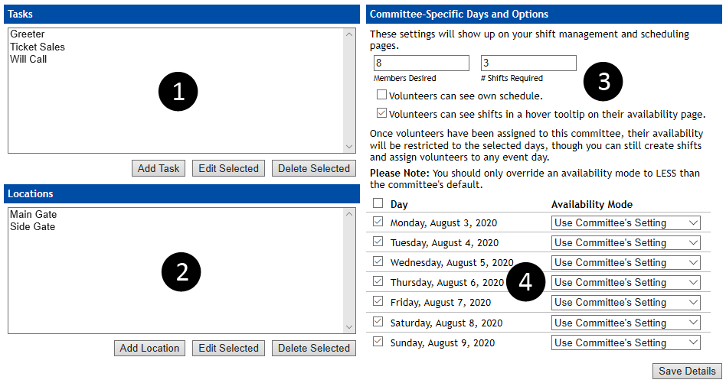
- Tasks are used by the scheduling tools to simplify the structure of your shifts. Instead of having a separate shift for each job, you can create a single shift and assign jobs during scheduling.
- Locations are similar to Tasks, and allow you to create a single shift and assign a position during scheduling.
- For the selected committee, you can change the number of volunteers you want, the number of shifts each volunteer should work, whether volunteers can see their schedules on the home page and whether the availability page should show the exact shifts in a hover tooltip.
- Your committee may not work every day the event is running. Use the check boxes to restrict what days are visible to volunteers and the scheduling tools. You can also use the availability mode dropdowns to show different numbers of availability blocks per day, but make sure to set the committee’s default to the maximum possible on any day or else you may get display issues.

Print Schedule
This tool allows you to print the work schedule for any of your committees, either for the entire event or a single day. You can print the page directly, or use the export links to download and print a CSV (Excel) or PDF version. If you’d like to format your schedule, the CSV option offers the most flexibility.
To print a fill-in version of your schedule that can be used for signups in person, check the Draw Empty Assignment Blocks checkbox.
If you won't have a computer on-site during the event, you can print off the schedule and use the Shift Check In tool when you get home at night.
If a shift has been cancelled or rescheduled, you can use the Message Shift link next to each shift to quickly compose a message addressed to the volunteers working the selected shift. If you need to message multiple shifts, use the Messaging by Schedule tool.

Report: Assignments by Hour
This report displays schedule coverage, or how many volunteers and chairs you have assigned to each hour of the day.
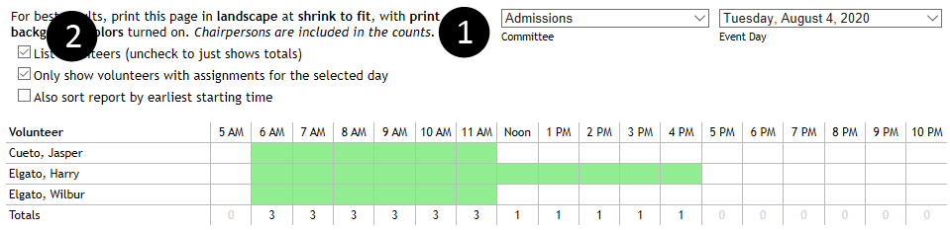
- Pick the committee and day you’d like to view.
- By default, the first two check boxes will be checked and the system will draw a line for each volunteer with an assignment for that day. You can change these options:
  - List volunteers – Toggles whether or not the system displays a list of volunteers or just the footer row with the final counts.
  - Only show volunteers with assignments for the selected day – If you’ve chosen to list the volunteers above, you can toggle whether the system shows all of a committee’s volunteers or just those with assignments.
  - Also sort report by earliest starting time – Before sorting alphabetically, the system will sort volunteers by their first starting shift, creating a cascaded view of the day’s schedule.
Like the Availability Table, this grid may have trouble printing on some printers or web browsers. See “How do I print the Availability Table?” under the Frequently Asked Questions section for tips.

Report: Attendance
The volunteer attendance report provides a variety of useful information, including the number of volunteers desired per shift, the number of volunteers assigned to each shift, and the number of volunteers who showed up to work. You can filter by committee, event day and time of day and the results are color-coded.
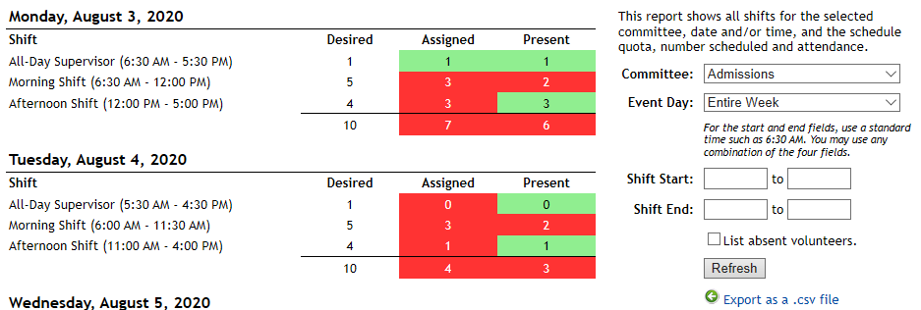
Columns to the right with less than the desired number will be red. Columns with the desired number or more will be green.
The toggle to List Absent Volunteers will show which volunteers missed their assigned shifts. The Export to CSV will export the data to Excel, allowing you to apply custom formatting.

Schedule Problems
The system both collects and detects potential schedule problems and combines them for you on this tool. The top half is made up of problems reported by volunteers on their home page:
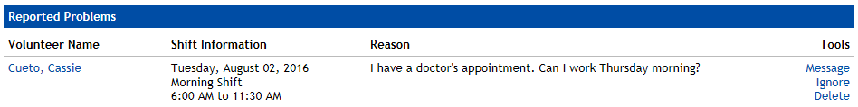
Each problem is displayed with the volunteer’s name, the name, date and time of their shift, the reason for the report and a set of tools:
- Message lets you send an on-site or e-mail message to the volunteer for clarification.
- Ignore denies the request and will reset the status of the shift on the volunteer’s home page.
- Delete removes the assignment from the system, allowing you to schedule them for a replacement shift with one of the scheduling tools.

The bottom half of the tool is made up of overlapping shift assignments that the system has detected:
Like the example in the screenshot, you may purposely assign volunteers to overlapping shifts when they’re working multiple shifts on a single day. The Omit same-committee assignments checkbox will clean up the report and only show you conflicts between committees.

Search Directory
The directory search tool allows you to search the user directory on multiple criteria including name, e-mail address, account type, committee assignment and registration code. It can also be used to print an address book for your committee – see the FAQ section at the end of this document.
Once you’ve found the right person in the directory, click the View Profile link to view their profile or Send Message to message them directly. As a chairperson, you have full access to the profiles of your committee members, but you may only read some of the information in other profiles.

Shift Check In
This tool lets you check volunteers in as they show up for a shift. If you don't have a computer on site during the event, you can print your schedule and check them in at any later time.
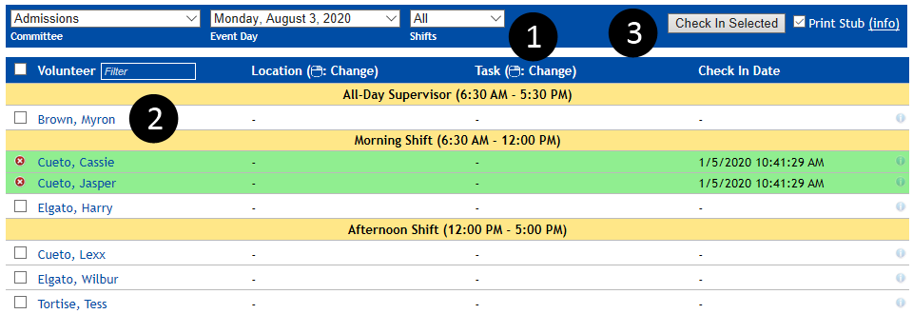
- Select a committee and day to see the list of volunteers assigned to work. You can further filter the displayed shifts by restricting the time of day.
- Check off one or more volunteers. Save time by using the master check box to select all volunteers and then uncheck any absent volunteers.
- Click the Check In Selected button to save your choices.
If a volunteer has already been checked in, the date and time of the check in will be visible and the line will be highlighted green. If you check in the wrong volunteer, you can un-do a check in by clicking the red X symbol on the left of the line.
Checking a volunteer in for a shift will cause that shift to display in green on their home page, showing that they received credit for working that shift.
The check in tool also has a few optional features that may help during check in:

Real Time Name Search
The column header for volunteer names has a white box which acts as a real time filter for the displayed names. Start typing the first few letters of a person’s first or last name and the list will hide anyone that doesn’t match.

Right-Click Quick Task/Location Change
If you are using tasks or locations, you can right-click on a person’s task or location assignment to see a dialog of available choices, including a count of current assignments. Making a change will reload the page with the updated assignment.

Check In Stub
If you’re checking people in as they show up to work, the system can print a stub with the person’s name, assignment, task and location. The stub can be printed on any printer, but works best on a receipt printer. If you want to use this option, click (Info) next to the Print Stub checkbox to see detailed instructions on setting up paper size and margins.

Notes
Click on the small (i) symbol next to an assignment to see or edit the notes associated with that assignment. This can be useful if you know a person will be checking in late or had to miss a shift. Lines with notes will be highlighted in blue.

Schedule by Grid
This tool allows you to schedule in a format similar to the availability table. Many people use this tool to set up initial schedules and then tweak assignments with the other two tools.
When you first load the tool, it will look similar to the availability table with a few extra options:
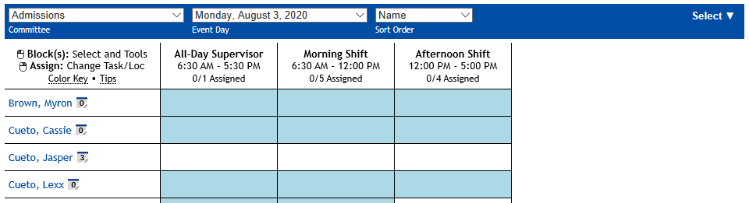
You can select blocks by clicking individually, clicking and dragging a box around multiple blocks or using the Select menu to select based on different criteria like availability. Selected blocks will turn orange and you’ll see a Selection Tools menu appear:
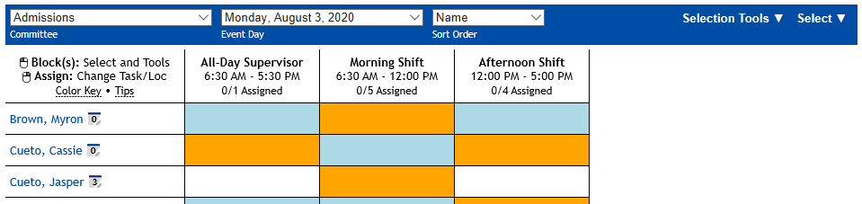
From that menu you can add or remove assignments and add or remove tasks and locations. As you make changes, the total shift count next to a person’s name and the shift volunteer count above each column will update:
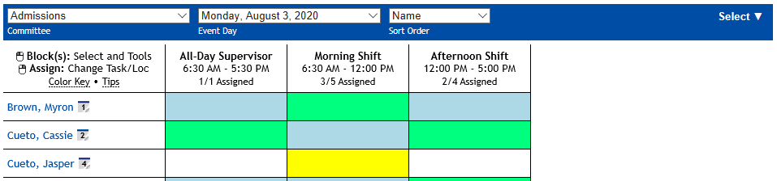
The colors are identical to the availability table and you can hover over the Color Key and Tips links for extra information at any time.
You can also right-click any block that has been assigned to adjust that assignment’s task and location instead of selecting the block and using the Selection Tools menu.

Schedule by Person
This tool allows you to approach scheduling on a person-to-person level. It is usually used to fine tune schedules once the bulk of the work is done by the Schedule by Shift tool.
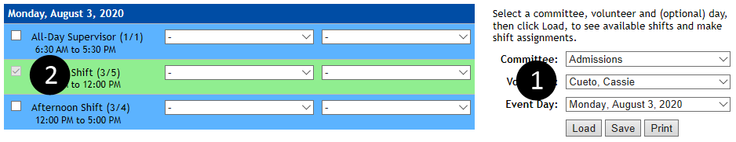
- Begin by selecting the committee, volunteer and event day that you’d like to work with. Click the Load button to load the selected volunteer’s schedule.
- When the schedule loads, the system will display all matching shifts, colored by availability and assignments.
  - Shifts in yellow indicate that a volunteer has been assigned, but did not mark it as available.
  - Shifts in blue indicate that a volunteer is available to work that shift.
  - Shifts in green indicate that a volunteer is both available and assigned.
  - Shifts in red indicate that a volunteer has flagged the assigned shift as a schedule problem.
- The check boxes to the left of each shift control assignment. Simply check or uncheck the boxes that correspond to the shifts and click Save to save your changes.
The Print button will take you directly to a printable version of the selected volunteer’s schedule.

Schedule by Shift
This tool allows you to approach scheduling from the perspective of filling up shifts. Most people use this after setting up an initial schedule with the grid-based tool.
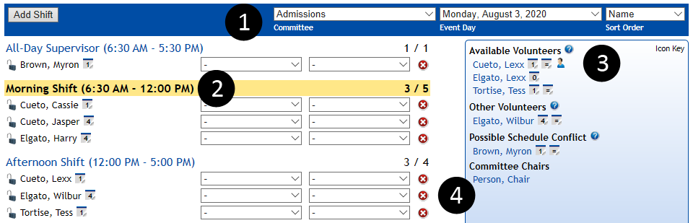
- Begin by selecting the committee and event day you’d like to work with. The system will load that day’s shifts into the left pane. You can also choose whether volunteers should be listed alphabetically or by the number of shifts they’re already working.
- Select a shift to begin assigning volunteers. The currently selected shift will be highlighted (orange above) and each shift will show the current number of assigned volunteers out of the desired quantity.
- Once a shift has been selected, the right pane will display all unassigned volunteers and chairs with some informational icons. To add a volunteer to the selected shift, click their name and it will move to the left pane. Names will be listed in up to four categories:
  - Available Volunteers – These volunteers selected this shift as one they could work.
  - Other Volunteers – These volunteers did not select this shift as available, but you can assign them anyway.
  - Schedule Conflict – The system detected an overlap with an existing assignment. Hover over the name for more information.
  - Committee Chairs – You can assign yourself and other committee chairs to any shift just like a volunteer.
- Once a volunteer’s name appears in the left pane, you gain several tools:
  - Use the drop down menus to pick a task and location for the assignment. These are optional; see the My Committees section for more information.
  - Use the red X symbol to remove a volunteer from a shift.
  - If your event is using the automatic scheduling tool, the lock icon will prevent the automatic scheduler from changing or removing this assignment.
The Add Shift button allows you to quickly add a single shift to the system, but you should make major changes through the Manage Shifts tool.

Volunteer News
The news system is made up of individual news posts and the discussion board that goes with each post. As a chairperson, you can post, discuss and moderate news for your committees.
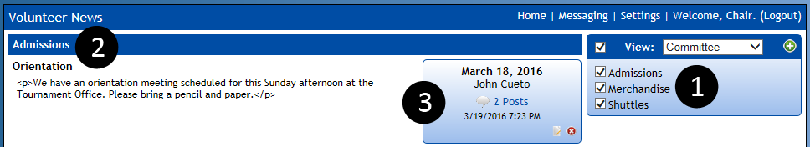
- Your committees will be listed in the right pane, all checked by default. To toggle news from a particular committee on or off, check or uncheck the corresponding check box. You can create a new post by clicking the green + symbol.
- Posts will be displayed grouped by committee. You can group by date using the View: drop down menu.
- Each post contains a toolbox showing the date and poster, how many posts are in the discussion board, when the last post was made and icons which allow you to edit or delete the post.
Discussion boards allow you and your volunteers to discuss the contents of a post. They’re a powerful tool that can eliminate large e-mail chains.
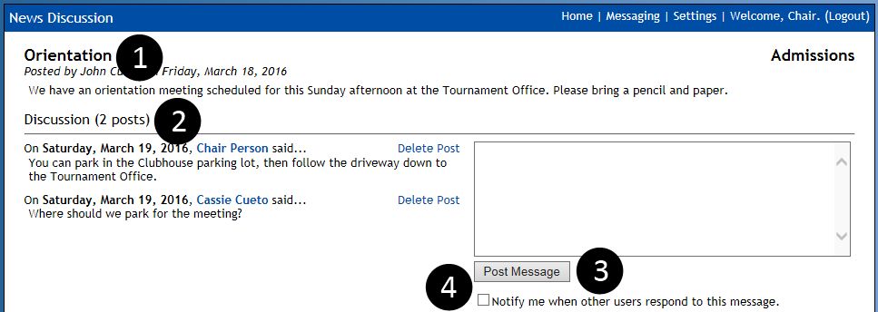
- The system will display some basic information about the news item, including the body of the post.
- Discussion posts are displayed in reverse chronological order. As a chairperson, you can use the Delete Post link to remove questionable material.
- Participate in the discussion by typing in the text box and hitting the Post Message button.
- Check the box to be notified by e-mail when people respond to the discussion.

Messaging
The messaging system is made up of several tools and gives you a great deal of flexibility in contacting your volunteers.
Onsite Messages are sent and read through the CEMS application’s messaging tools. Offsite Messages are sent via e-mail, appear to come from your e-mail address, and must be read and responded to through an e-mail program.

Messaging a Single Person

Via The Directory
- Open the Search Directory tool and use the search criteria to find the desired person.
- Click the Send Message link next to the directory entry.
- When the compose message screen appears, fill in a subject and body, pick or change any options, then click Send to send the message or Cancel to cancel.

Via My Committees
- Open the My Committees tool and use the drop down menu to select the desired committee.
- Check the box next to the desired target’s name.
- Go to the Tools menu and select Message Selected.
- When the compose message screen appears, fill in a subject and body, pick or change any options, then click Send to send the message or Cancel to cancel.

Messaging Multiple People

Via My Committees
- Open the My Committees tool and use the drop down menu to select the desired committee.
- Check the box next to the desired targets’ name(s).
- Go to the Tools menu and select Message Selected.
- When the compose message screen appears, fill in a subject and body, pick or change any options, then click Send to send the message or Cancel to cancel.
To quickly select all volunteers in the selected committee, use the master check box at the top of the roster.

Tracking E-Mail Read Status
The system includes a tracking pixel in all outgoing messages so we know when a message is read – as long as the person’s e-mail program doesn’t block images. You can see the onsite and offsite read status of a message by:
- Click Messaging in the upper right and change the view to Sent Messages.
- Click on a message. You’ll see a percentage read rate for onsite and offsite messages and can expand the read report to see the status by recipient.

Frequently Asked Questions (FAQ)

How do I set up an account?
A chairperson account has access to powerful tools and sensitive information so the registration process is not open to the public. Your contact at the event will give you:
- A registration code and a link to the registration page.
OR
- A username and password and a link to the login page.
When you log in for the first time, the system will walk you through a registration wizard. For more detail on the steps, refer to the section “My Tasks” earlier in this document. Subsequent logins will take you directly to your home page.

How do I print an address book for my committee?
- Open the Search Directory tool, and pick the desired committee in the committee drop down menu.
- Click the Search button.
- Go to your web browser’s menu and select print. For most people, the default printer settings work fine.

How do I print the Availability Table?
- Go to the Page Setup menu on your browser, and tell the printer to use landscape.
- On the Page Setup or Printer Settings menu, look for the option to print background colors, and enable this.
- Open a Print Preview and set the zoom to 70% - 80% before clicking the button to print.

What are the steps to schedule a volunteer?
- Use the Manage Shifts tool to create your schedule.
- Use Schedule by Grid, Schedule by Person or Schedule by Shift to assign volunteers to shifts.
- Use My Committees to set schedules to visible and e-mail volunteers their schedule.
- Use Shift Check In to record attendance.

Who should I contact for help?
You're never on your own when you're using our software. Your event will probably assign a staff member to manage volunteers but we're here to help, too. If you want to report a problem or make a suggestion, e-mail John at john@cuetoems.com.

