Customer Ticket
Dashboard

Cueto Event Management System | December 2019
Table of Contents
Introduction 3
Contact Info 3
Terms of Use 3
What is the Customer Ticket Dashboard? 4
Delivery Methods 4
Supported Devices 4
Optional Features 4
Dashboard Home 5
Allocated Items 5
Guest Cancellations 5
Exporting Orders 6
Tools 6
Settings 7
Send Tickets 8
(Optional) Step 1: Select Delivery Method 8
Step 2: Pick Items to Send 8
Step 3: Customize Message 8
Step 4: Add Recipients 9
Guided 9
Upload File and Free-Form 9
Free-Form 9
Optional Feature: Request Tickets 10
Optional Feature: Purchase Capacity 11
Message Links and Variables 12
Bracket Links 12
Regular Variables 12

Introduction
This guide is intended to cover the Customer Ticket Dashboard for the Cueto Event Management Software. The guide is current as of December 2019 and new versions will be published for each major revision.

Contact Info
Cueto & Cueto, Inc. is the company responsible for developing, maintaining and hosting the Cueto Event Management Software. We welcome – and appreciate - your questions and feedback about the software, website and manual.
The best way to get in touch with us is through e-mail at john@cuetoems.com. You can also use our contact form:
http://www.cuetoems.com/Contact.aspx
If you’re associated with an event, please put the name of the event in the subject of the message so the correct person gets your message. Due to our travel schedule, it may take us several days to respond.

Terms of Use
This document in its entirety is Copyright 2019 Cueto & Cueto, Inc. It may be copied or distributed, in part or in whole, by any of our customers, or agents acting on their behalf, for purposes of education and training.
This document may not be used for purposes of reverse engineering or duplication of the Cueto Event Management Software.
The most recent version can always be found at:
http://www.cuetoems.com/Help.aspx

What is the Customer Ticket Dashboard?
The CEMS Customer Ticket Dashboard lets you send tickets to your customers, guests and employees. Multiple people at your organization can use the dashboard at once and you can come back at any time to send more tickets, view the status of sent tickets or cancel tickets that you’ve sent.

Delivery Methods
The default delivery method is print online, or electronic delivery via PDF and/or cell phone ticket. Events that have will call locations for physical tickets may offer this as an additional delivery method. If so, you’ll see this show up automatically on the tools to send tickets.
If you need assistance with adding or changing delivery options, please reach out to your contact at the event.

Supported Devices
The dashboard and any received tickets can be used from a computer, tablet or phone. The images in this manual correspond to the computer version. The mobile versions are identical in function, but have a slightly different layout.
If you’re having trouble with the site, make sure that you’re allowing scripts and cookies from the cuetoems.com domain and that your web browser is up to date.

Optional Features
The dashboard offers several optional features, such as the ability the request or purchase additional capacity from the event. We’ll show you where those optional features can appear and how to use them later in the guide.

Dashboard Home
Your contact at the event will send you a link that will take you to this page:
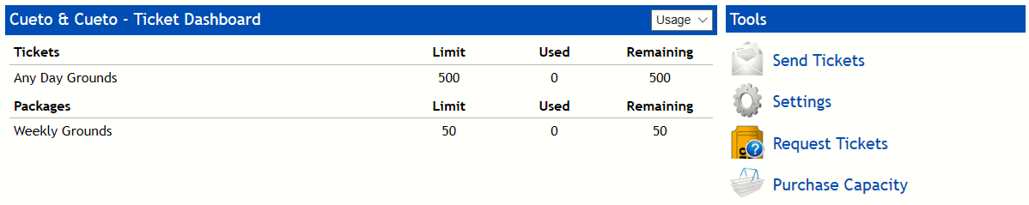
The left part of the screen shows the items you’ve allocated, how many you’ve used and how many are still available.
The right part of the screen shows the tools you can use to send tickets and change settings. You may see icons to request or purchase additional capacity. The rest of the manual will cover each tool in detail.

Allocated Items
By default, this table shows you a list of each ticket type available to you with the quantities allocated, used and remaining. For your convenience, items are broken down into Tickets (a single-page electronic ticket) and Packages (comprised of multiple single-page electronic tickets, such as a weekly pass).
You can use the drop down menu to switch to the orders view:
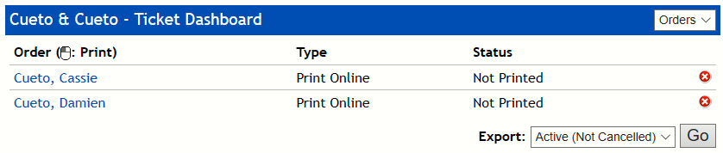
This view shows each batch of tickets you’ve sent, the delivery method (print online or will call) and the status (not printed or picked up, printed/picked up but not unused, or printed/picked up and used).
For print online orders, you can click the guest’s name to print their tickets yourself.
You can cancel an order by clicking the red X symbol and the tickets will return to your available quantities. Cancelled orders will remain in the list, highlighted in red.

Guest Cancellations
As you’ll see later, your outgoing messages can include a link which allows customers to decline their electronic tickets. When a customer clicks this link, their tickets are immediately returned to your available quantities.

Exporting Orders
The export drop down menu allows you to export the name, e-mail address, items on the order and order status for either all orders or all non-cancelled orders.

Tools
We’ll detail each of the four tools in the next four sections. Please keep in mind that the Request Tickets and Purchase Capacity features are optional and may not show up for your account.

Settings
The settings page allows you to update the default e-mail address, message subject, and print online and will call message bodies for your account.
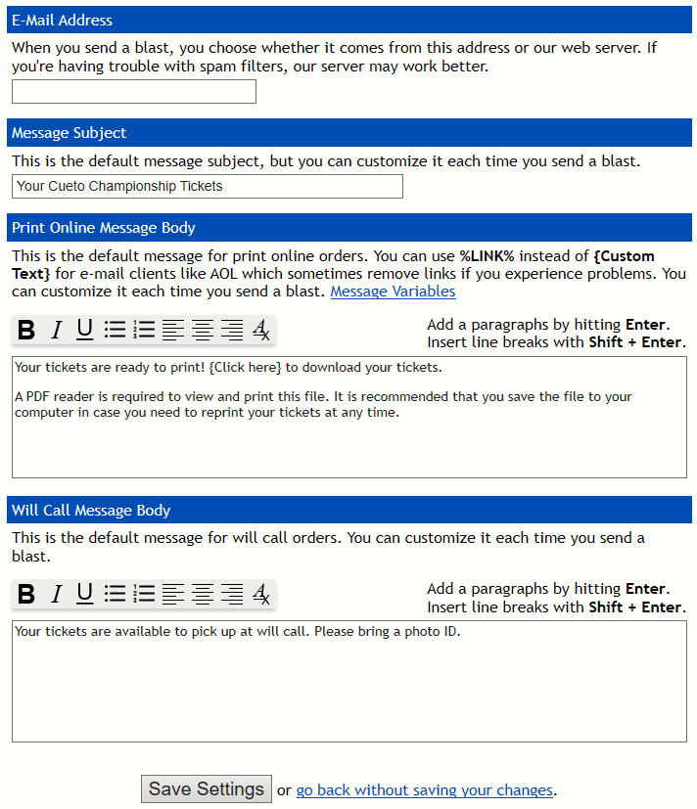
To change these values, simply update the values in the text boxes and click the “Save Settings” button. If you want to cancel your changes or just leave the page, click the link that says “go back without saving your changes” to return to the dashboard home page.
The e-mail address is the one from which your ticket e-mails will appear to come. As you’ll see later, you can choose to send each blast from this address or a generic catch-all address associated with our web server. If you’re having trouble with spam filters, you should try sending your blasts from our address.
The default subject and body will be filled in for you each time you send a new blast, but you’ll have the opportunity to customize both of them before sending the message. The message body may contain a number of variables which are explained in the Message Links and Variables section at the end of this document. You can format your message using the formatting buttons, just like using a word processor.

Send Tickets
The Send Tickets page will guide you through a three- or four-step process, depending on this event’s settings.
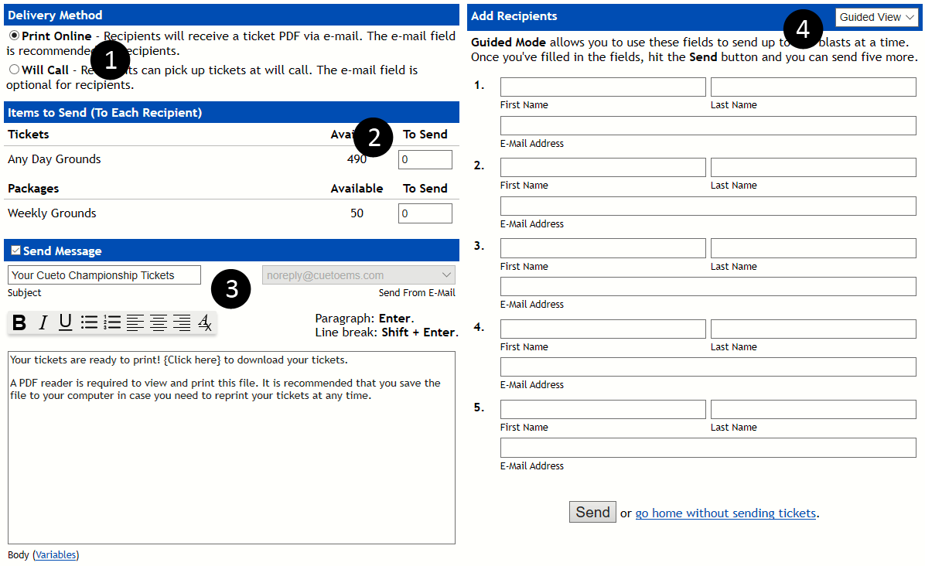

(Optional) Step 1: Select Delivery Method
If the event gives you the choice between print online and will call, select your preference here. If you don’t see this section, your tickets will be sent via print online.

Step 2: Pick Items to Send
Use the text boxes under the “To Send” column to input the quantities of tickets to be distributed to each recipient. The system will not allow you to send a message without any tickets, nor will it allow you to send a message with more than the available quantity of each type of ticket.

Step 3: Customize Message
By default, the system will send a message to each recipient, but you can disable this by unchecking the Send Message box.
Every time you send tickets, the subject and body fields will be pre-populated with your defaults. Any changes you make for an individual blast will not overwrite the default values. See the Message Links and Variables section at the end of this document for a list of variables.
You’re also given the opportunity to select the sending e-mail address. If you have an e-mail address in the system it will be selected by default, but you can use the drop down menu to select “noreply@cuetoems.com” to have the message come from our e-mail server if you’re having trouble with spam filters.

Step 4: Add Recipients
There are three ways to add recipients to your ticket blast, depending on your level of experience with computers.

Guided
New users may prefer the default Guided option for adding requests. In this mode, you use the labeled fields to add up to five recipients at a time.
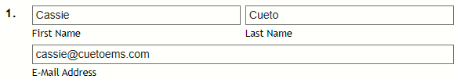
The first and last name are mandatory. The e-mail address is optional if the Send Message box is unchecked or the tickets are being sent to will call.

Upload File and Free-Form
You can upload a CSV or TXT file containing recipients or copy and paste recipients into the Free Form text box in the same format. Each recipient must be own their own line, with the first name in the first field, the last name in the second field and the e-mail address in the third field.
A sample with two recipients would look like:
Cassie,Cueto,cassie@cuetoems.com
Damien,Cueto,damien@cuetoems.com

Free-Form
The Free-Form option allows you to use a text box to add an unlimited number of recipients at a time.
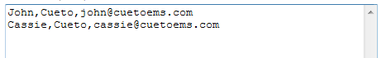

Once your recipients are ready, click the “Send” button. The system will perform a number of safety checks, including quantity limits and verifying your list of recipients, before processing and sending this blast. When it’s finished you’ll be shown this message and allowed to proceed:

Optional Feature: Request Tickets
If you have the Request Tickets icon on your dashboard, the event has given you the ability to request additional capacity without paying online.
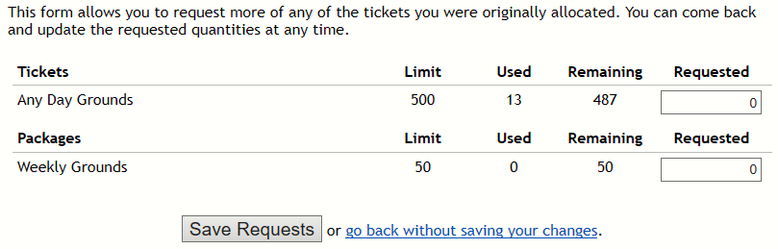
You’ll see a list with each type of ticket you have access to, along with the original quantity, number you’ve used and how many are left.
Enter a value in the Requested column and then click Save Requests. Your contact at the event will need to approve the request before you have access to the additional tickets.

Optional Feature: Purchase Capacity
If you have the Purchase Capacity icon on your dashboard, the event has given you the ability to purchase a certain number of additional tickets.
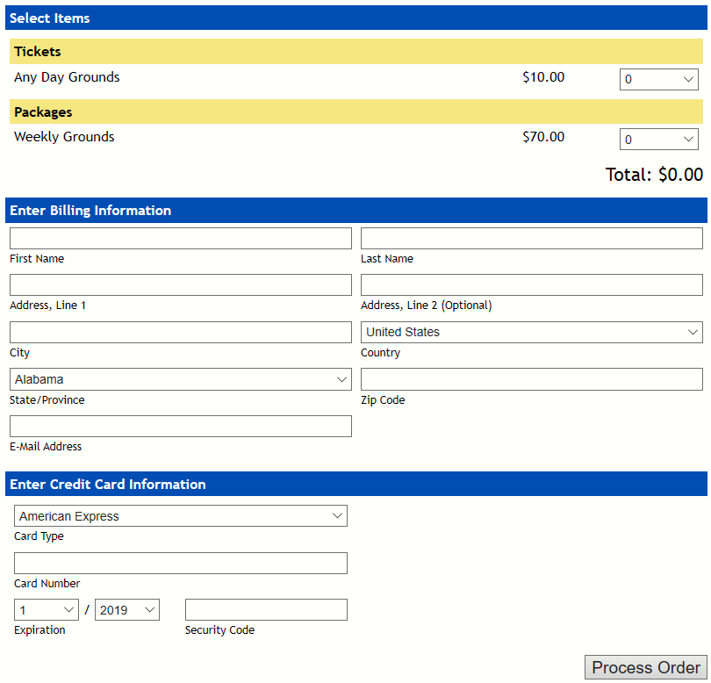
You’ll see a list with each type of ticket you’re allowed to purchase and a drop down with the maximum quantity for each type. As you select quantities, the subtotal, tax and total will update.
Fill out the billing and credit card information sections completely and then click Process Order once. It may take a few seconds to process, then you’ll be sent a confirmation e-mail and your additional tickets will be available immediately.

Message Links and Variables
The system provides a number of variables, which will automatically fill in information about the order. You can use these on the Settings page and when sending tickets.

Bracket Links
In the screenshots above, you may have seen the text “{Click here} to download your tickets.” This is an example of a bracket link, which will replace the text inside the brackets with a clickable link once the message is sent.
Text inside {curly brackets} is equivalent to the %LINK% variable below, and creates a link that allows the recipient to download their tickets. Text inside [square brackets] is equivalent to the %CANCEL% variable below, and creates a link that cancels an order.

Regular Variables
Using a variable is as simple as inserting it in your message. For instance, the %DATE% variable will insert the date and time that the order was placed. If your message contains the text:
Your ticket order was placed on %DATE%. We are very excited…
The customer will get:
Your ticket order was placed on 10/13/2020 at 3:45 PM EST. We are very excited…
Variable | Function
%CANCEL% | Generates a link which will allow your guest to cancel their tickets. The text of the link will also be the cancel URL.
%DATE% | Inserts the date and time which the order was placed.
%FIRSTNAME% | Inserts the guest’s first name.
%LINK% | Generates a link for your guest to download their tickets. The text of the link will also be the download URL.  The message must contain this variable or text inside {curly brackets} to continue.

